Creating an Cared Companion Network app

Help to the seniors, they friends and family members. Here's a breakdown of features for both the elderly person and caretaker interfaces:

**Cared Person Interface:**

* Profile Setup:

Allow seniors to create profiles with information about their interests, hobbies, and any specific needs or preferences they may have.

* Companion Matching:

Implement a matching algorithm to connect seniors with suitable companions based on shared interests, availability, and proximity. Duration for care.

* Appointment Scheduling:

Enable seniors to schedule companionship sessions, assistance with chores, or transportation services through the app.

* Emergency Assistance Button:

Include an emergency button that seniors can press to quickly alert their designated caretaker or emergency services in case of need.

* Feedback and Ratings:

Provide a rating and feedback system to allow seniors to rate their companions, ensuring a positive experience and helping improve the service.

* Chat and Communication:

Include a secure chat feature for easy communication between seniors and their assigned companions.

* Event Calendar:

Allow seniors to view and participate in local community events, gatherings, or virtual meetups to further encourage social engagement.

* Reminders and Notifications:

Implement reminders for appointments, medication schedules, and other important events.

* History of visits with reports from Caregiver.

**Caretaker Interface:**

Registration and Verification:

Ensure caretakers undergo a thorough registration and verification process, including background checks to ensure the safety of the seniors.

Companion Matching Dashboard:

Provide a dashboard that displays available requests from seniors, allowing caretakers to choose companionship opportunities based on their availability and skills.

Schedule Management:

Include a calendar to manage upcoming appointments, track completed sessions, and plan their availability for future companionship opportunities.

Emergency Response System:

Integrate a system that allows caretakers to receive alerts in case of emergencies or urgent needs from the seniors they are assisting.

Communication Hub:

Incorporate a messaging system to facilitate communication between caretakers and seniors. This can include updates on activities, schedules, and any changes in plans.

Feedback and Improvement:

Provide a platform for caretakers to receive feedback from both the seniors and the app administrators. This helps in continuous improvement and ensures the quality of service.

Training and Resources:

(Roadmap to improve career)

Offer training materials and resources for caretakers to enhance their skills in providing companionship, assistance, and understanding the needs of elderly individuals.

Community Support Forum:

Establish a forum where caretakers can share experiences, seek advice, and build a supportive community among themselves.

User friendly and Accessability design. (Changing of fonds by requirements, text to speech)

This one you can also add a pain tracker and give the analysis to the patient and share it with the caregiver.

Compare contrast functionality with another application:   
  
* What we have and have with another but in different way or different focus.

Have most listed functionalities, however not emergency button and no auto matching of companion.

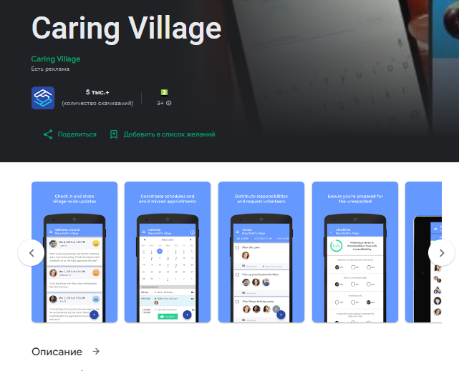

Creates planer and calendar, however without choosing people who care.

Good visit planner. Uses only for care giver peoples.

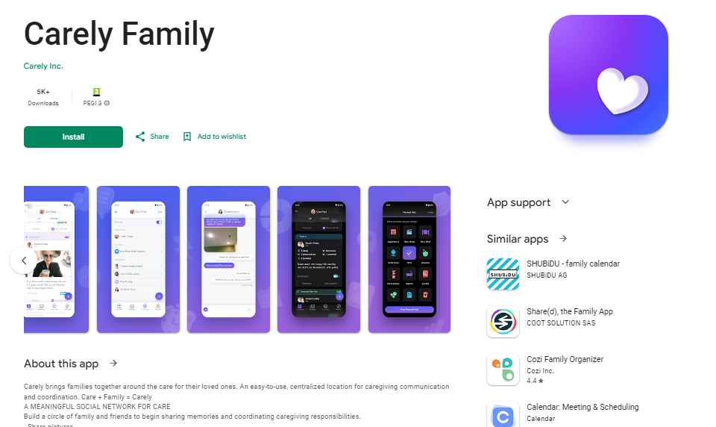

https://play.google.com/store/apps/details?id=com.care.android.careview.providerapp

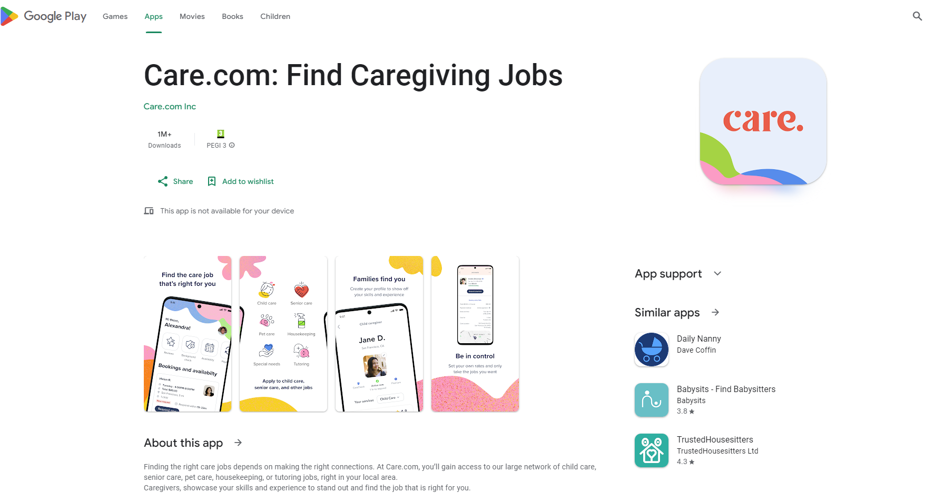

* Availability to check available caregivers however not giving calendar and routine builder.